Performance Analyzer in Power BI Desktop
First, we need to start Performance Analyzer in Power BI Desktop:
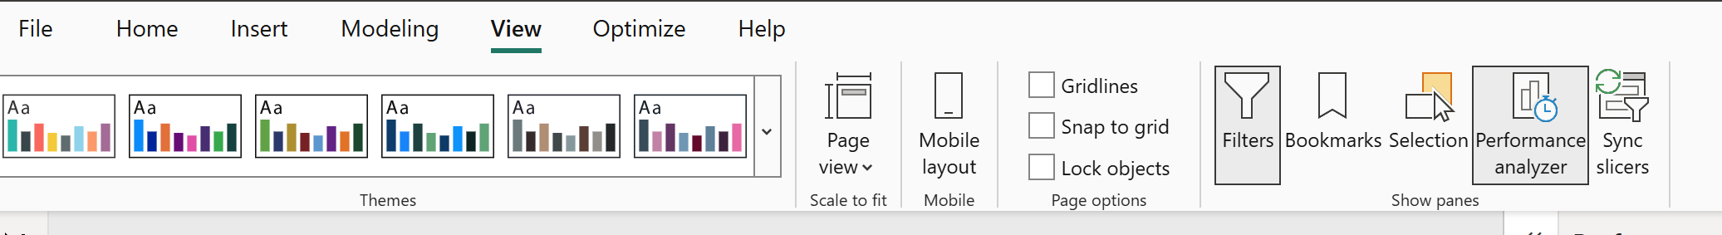
As soon as we see the Performance Analyzer Pane, we can start recording the performance data and the DAX query for all Visuals:
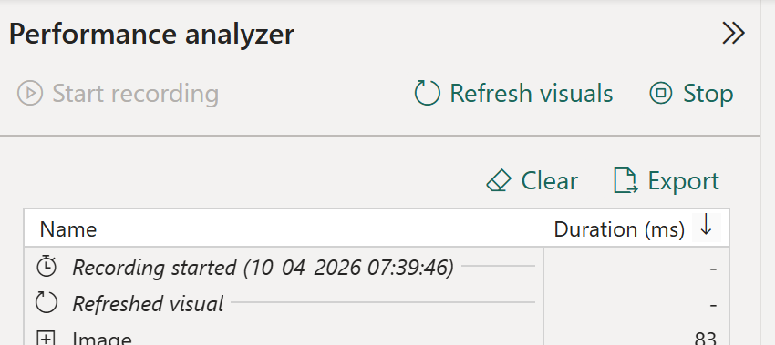

First, we must click on Start Recording
Then click on “Refresh Visuals” to restart the rendering of all Visuals of the actual page.
We can click on one of the rows in the list and notice that the corresponding Visual is also activated.
When we expand on one of the rows in the report, we see a few rows and a link to copy the DAX query to the Clipboard.
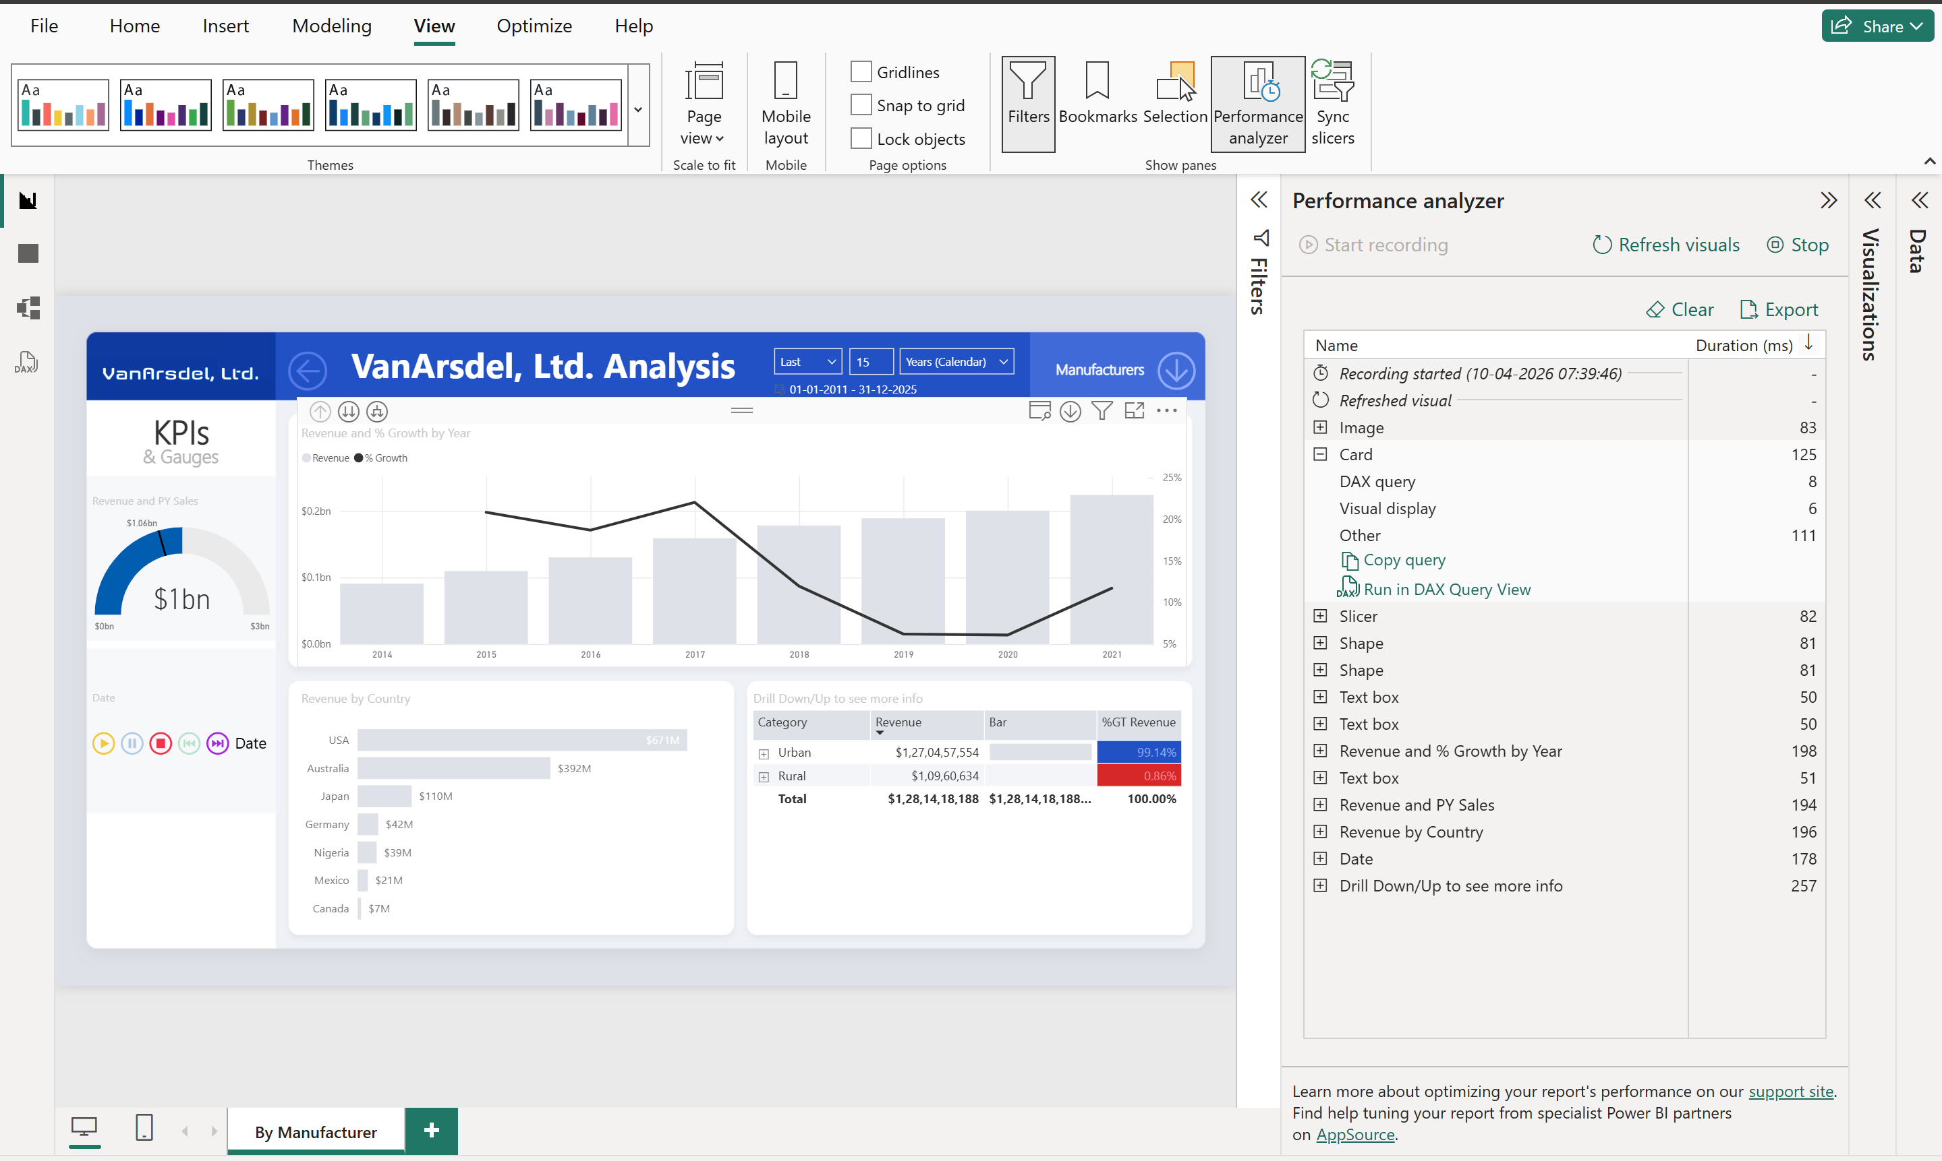

Now, we can start DAX Studio.
Download from here DAX Studio
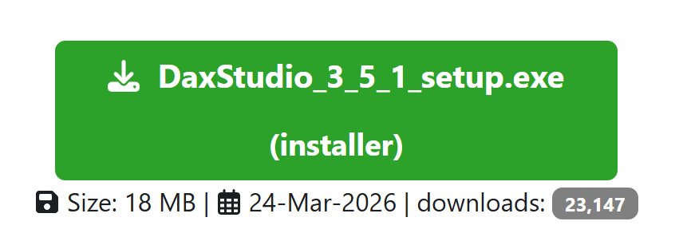
we must start DAX Studio manually; we can manually connect to the Power BI file as well:
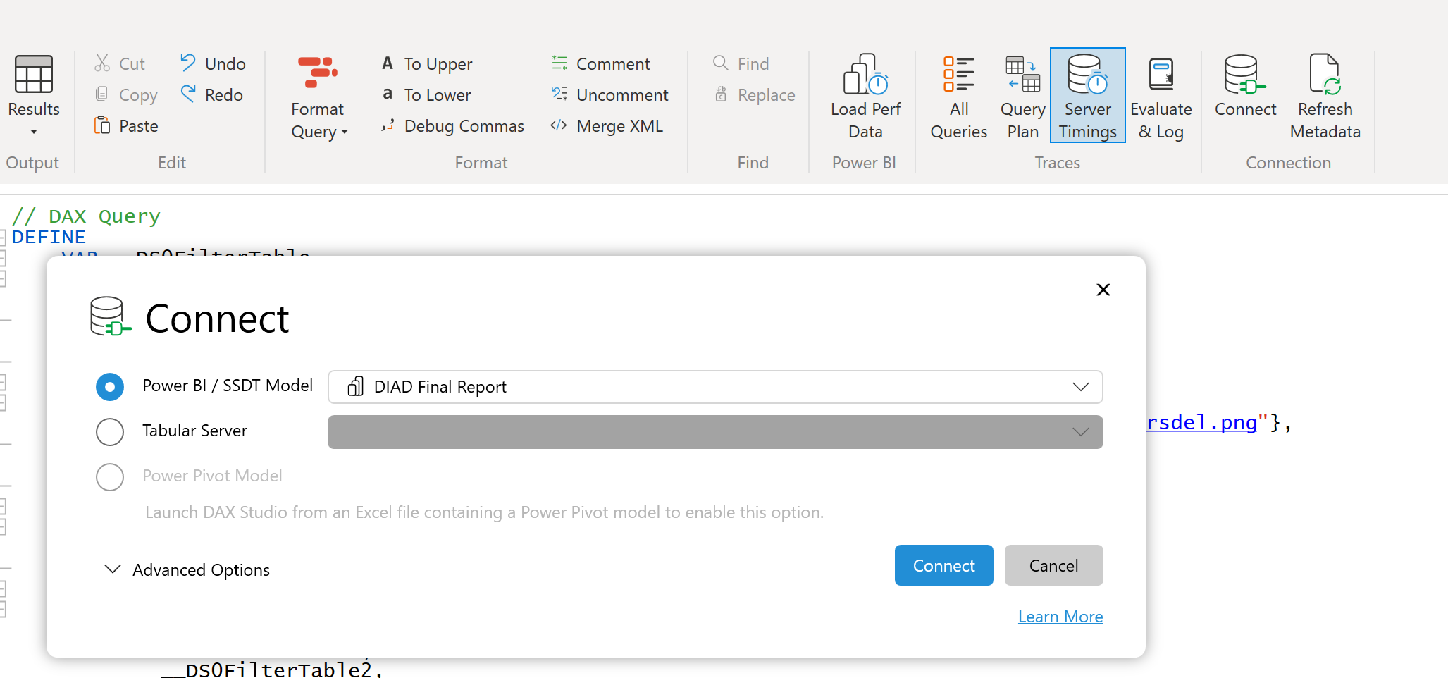
After the connection is established, an empty query is opened in DAX Studio.
On the bottom part of the DAX Studio Window, you will see a Log section where you can see what happens.
But, before pasting the DAX Query from Power BI Desktop, we have to start Server Timings in DAX Studio (Right top corner of the DAX Studio Window):
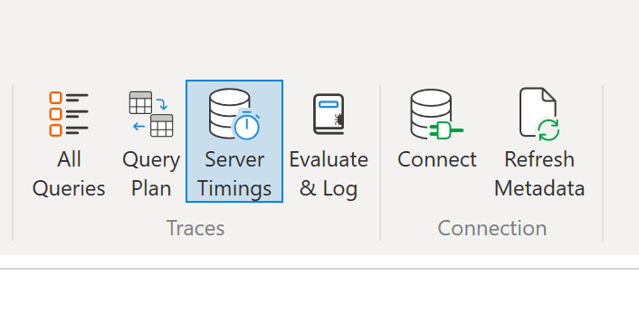
Copy the query from Power BI Performance Analyzer
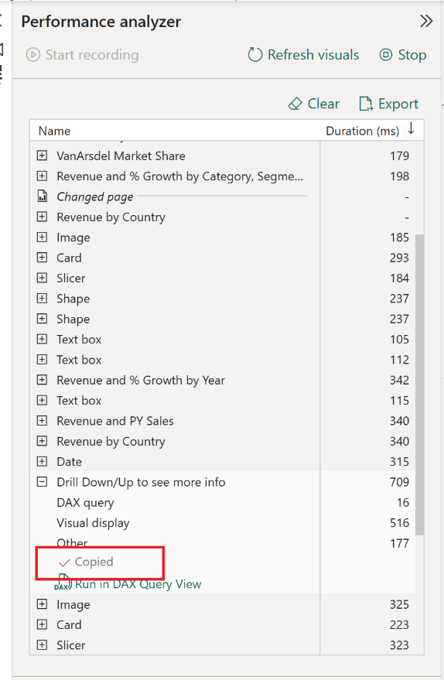
Paste the code in DAX Studio
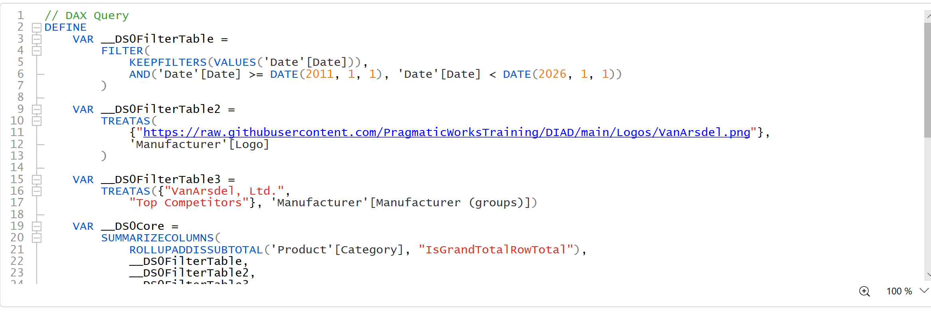
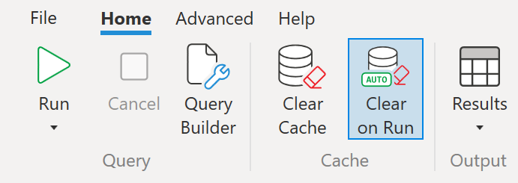
After pasting the Query to the Empty Editor, we have to Enable the “Clear on Run” Button and execute the query.

“Clear on Run” ensures the Storage Engine Cache is cleared before executing the Query.
Clearing the Cache before measuring performance metrics is the best practice to ensure a consistent starting point for the measurement.
After executing the query, we will get a Server Timings page at the bottom of the DAX Studio Window:
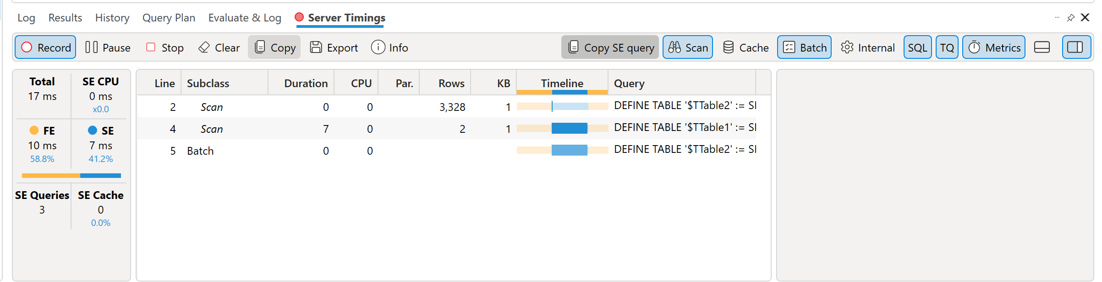
Interpreting the data
On the left side of Server Timings, we will see the execution timings:
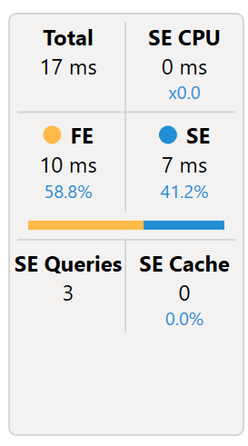
Here we see the following numbers:
- Total – The total execution time in milliseconds (ms)
- SE CPU – The sum of the CPU time spent by the Storage Engine (SE) to execute the Query.
Usually, this number is greater than the Total time because of the parallel execution using multiple CPU Cores
- FE – The time spent by the Formula Engine (FE) and the percentage of the total execution time
- SE – The time spent by the Storage Engine (FE) and the percentage of the total execution time
- SE Queries – The number of Storage Engine Queries needed for the DAX Query
- SE Cache – The use of Storage Engine Cache, if any
As a rule of thumb: The larger the percentage of Storage Engine time, compared to Formula Engine time, the better.
The middle section shows a list of Storage Engine Queries:
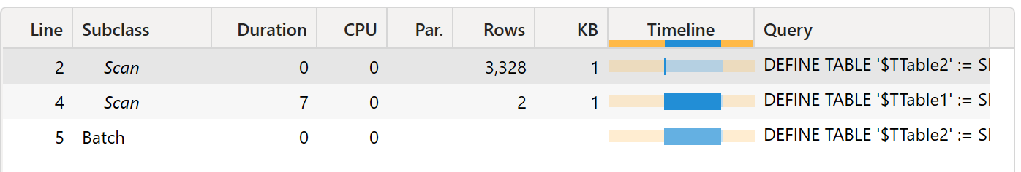
This list shows how many SE Queries have been executed for the DAX Query and includes some statistical columns:
- Line – Index line. Usually, we will not see all the lines. But we can see all lines by clicking on the Cache and Internal buttons on the top right corner of the Server Timings Pane. But we will not find them very useful, as they are an internal representation of the visible queries. Sometimes it can be helpful to see the Cache queries and see what part of the query has been accelerated by the SE Cache.
- Subclass – Normally “Scan”
- Duration – Time spent for each SE Query
- CPU – CPU Time spent for each SE Query
- Par. – Parallelism of each SE Query
- Rows and KB – Size of the materialization by the SE Query
- Waterfall – Timing sequence by the SE Queries
- Query – The beginning of each SE Query

After the Analyse the measure Growth
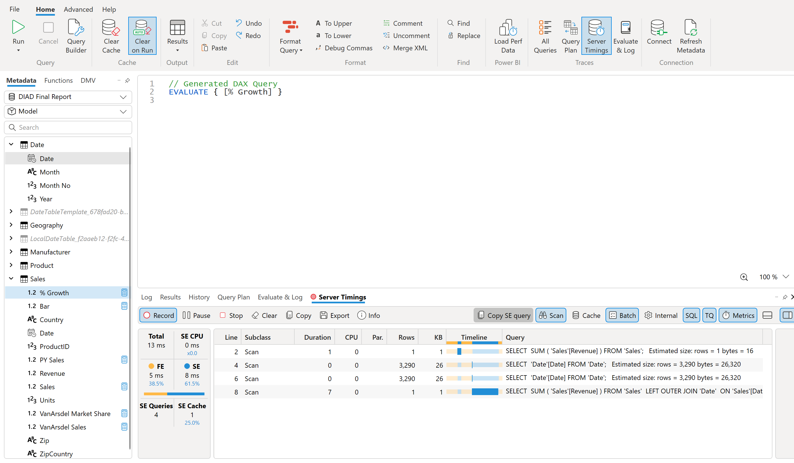
See the msSQL Query
SELECT SUM ( 'Sales'[Revenue] ) FROM 'Sales'; Estimated size: rows = 1 bytes = 16
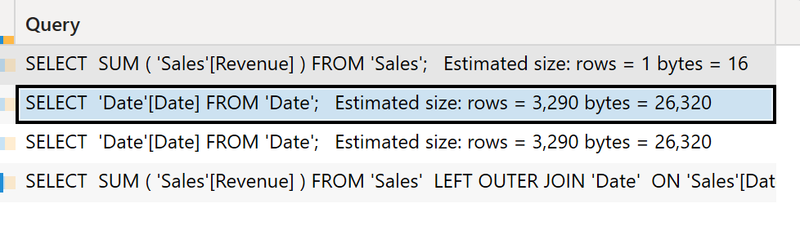
Steps to Follow
We need some information when we have a slow Visual in your Power BI Report.
The first step is to use Performance Analyzer in Power BI Desktop to see where time is spent rendering the result of the Visual.
When we see that it takes much time to execute the DAX Query, we need DAX Studio to find out the problem and try to fix it.

